# CS 255 System Design Document Template

## UML Diagrams

### UML Use Case Diagram

### UML Activity Diagrams

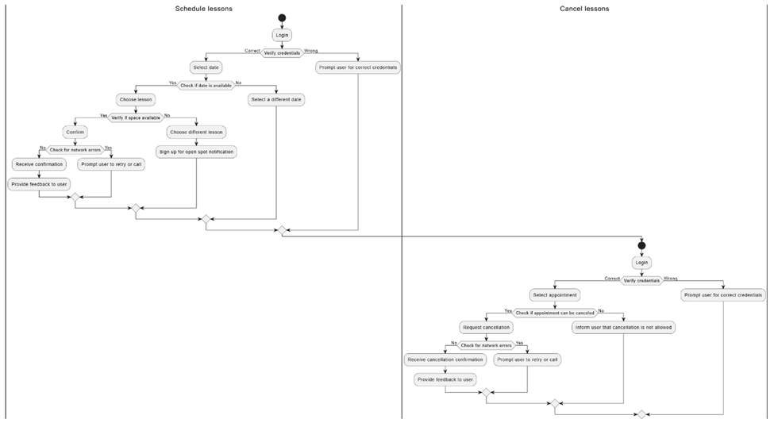

### UML Sequence Diagram

### UML Class Diagram

## Technical Requirements

**1. Hardware Requirements**

* **Server Infrastructure**: Robust server infrastructure to handle web and database services, capable of supporting up to 1,000 concurrent users as specified. This might include both application servers and database servers to ensure scalability and reliability.
* **Networking Equipment**: High-capacity network switches and routers to ensure fast and secure data transmission.
* **Workstations**: High-performance computers for administrative staff to manage the system, with dual monitors to enhance productivity during system monitoring and maintenance.

**2. Software Requirements**

* **Operating System**: The server infrastructure should run on a reliable and secure operating system such as Linux for the servers and Windows 10 for workstations.
* **Database Management System**: A robust DBMS like PostgreSQL or MySQL should be used to manage data storage, retrieval, and manipulation efficiently while ensuring data integrity and security.
* **Web Server Software**: Apache or Nginx web server software to handle requests from the internet and serve the DriverPass web application to users.

**3. Development Tools**

* **Integrated Development Environment (IDE)**: Tools like Visual Studio or Eclipse will be essential for the development of the system, providing environments that support coding, debugging, and testing functionalities.
* **Lucidchart**: Used for creating and managing UML diagrams, which help in planning and visualizing system architecture and workflows.
* **Version Control System**: Tools like Git, hosted on platforms such as GitHub or Bitbucket, to manage changes to the project's codebase, ensuring team collaboration and code integrity.

**4. Infrastructure and Services**

* **Cloud Hosting Services**: Utilize cloud platforms like AWS or Azure for hosting the web application and database. This provides scalability, reliability, and enhanced security while reducing the need for physical hardware maintenance.
* **Security Services**: Implementation of firewalls, SSL certificates for secure HTTP requests, and regular security audits to protect data and system access.
* **Backup and Recovery Solutions**: Automated backup solutions to ensure data is regularly backed up off-site. Implement disaster recovery plans to restore system functionality quickly in case of system failure.

**5. Compliance and Security**

* **Data Encryption**: Encryption of sensitive data both at rest and in transit using industry-standard encryption protocols to protect customer and business data.
* **User Authentication and Authorization**: Implement OAuth for secure, token-based user authentication. Role-based access controls (RBAC) to ensure users have access only to the features necessary for their role within the system.
* **Compliance**: Ensure compliance with relevant legal and regulatory requirements, such as GDPR for data protection and PCI DSS for payment processing.

By addressing these technical requirements, the DriverPass system will be robust, secure, and capable of meeting the current and future needs of the business, ensuring a smooth operation and excellent user experience.